Secular Franciscan Order (OFS)
(Third Order of St. Francis)

Are you interested in the Franciscan way of life as a lay person?

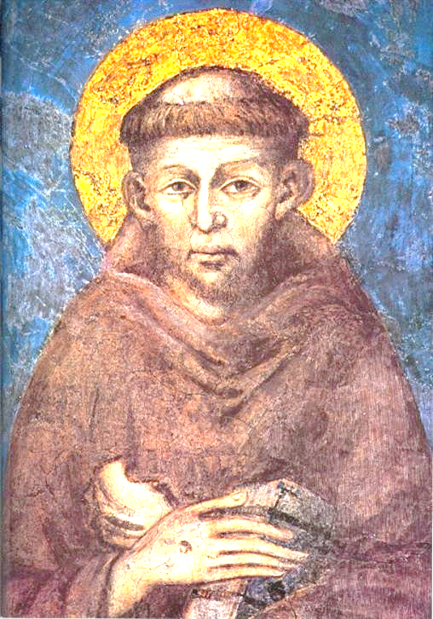

Website: ofsireland.org
The Secular Franciscan Order (Third Order) was founded in 1221 by St. Francis for lay people and diocesan clergy. It now has 200,000 members in over 100 countries.
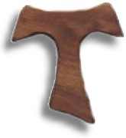
Secular Franciscan Order (OFS)
(Third Order of St Francis)
St. Francis founded his Third Order in 1221 for lay people and diocesan clergy.

MISSION
To follow Jesus Christ in the footsteps of St. Francis while remaining in our state of life as lay people.
WHY DID ST. FRANCIS FOUND THE ORDER?
Many people at the time of St. Francis were inspired by his life and preaching, and wanted to live their lives simply according to the spirit of the Gospel. They could not join the First Order (Friars), or Second Order (Poor Clares), because of family commitments and other obligations. For these disciples, Saint Francis founded his Third Order.
WHO IS IT FOR?
Jeus said: “I did not come to call the virtuous but sinners to repentance”. The OFS is for people who wish to grow in their love of God and their neighbour in the spirit of St. Francis.
TITLE
The official name is Ordo Franciscanus Sæcularis with the abbreviation OFS. In English, it is translated as the Secular Franciscan Order.

HOW TO BECOME A MEMBER
The Secular Franciscan Order (OFS) belongs to the Franciscan Family. It is formed by the union of all its Catholic fraternities throughout the world. The members commit themselves to live the Gospel after the manner of St. Francis. They do so in their lay circumstances following the Rule approved by the Church. Instruction is given on this way of life at monthly formation meetings lasting about eighteen months. Then, those in formation can decide to be professed as a member of the Order.
You are invited to find out more about the OFS way of life by entering your information in this form and handing it into the Friary Office. Alternatively, you can visit the “Contact” section of our website ofsireland.org.
Please fill out in BLOCK CAPITALS
NAME: ________________________________________

ADDRESS: _________________________________________
__________________________________________
__________________________________________

Phone Number: _________________________________

Email: ____________________________________________
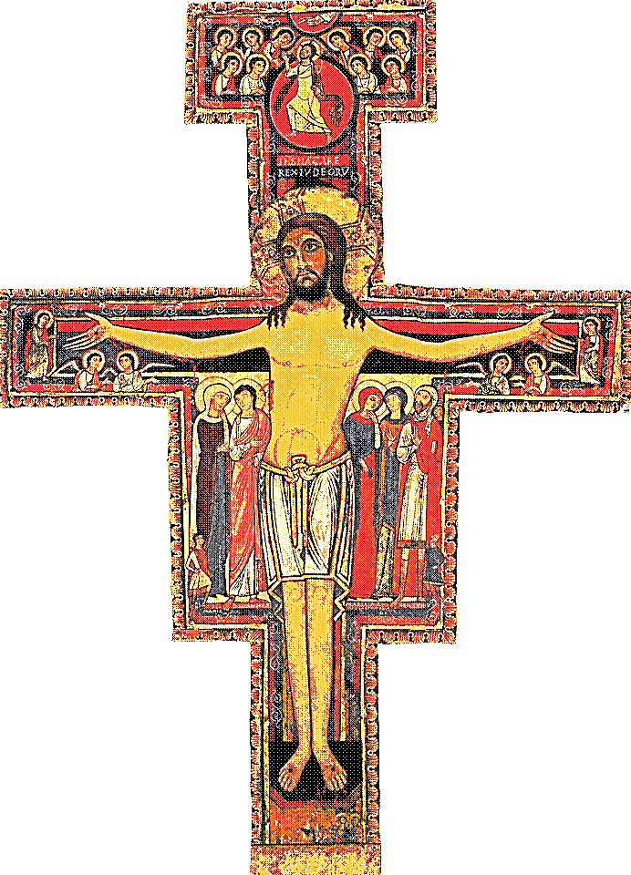
St. Francis of Assisi was praying before the San Damiano Cross when he received his mission from the Lord to “Rebuild my Church”. The cross now hangs in the Basilica of Saint Clare in Assisi. Franciscans especially revere this cross as a sign of their mission from God.

